MongoDB Tasks:

Task 1: Create a db using mongodb:
Task 2: Create a collection using mongodb:
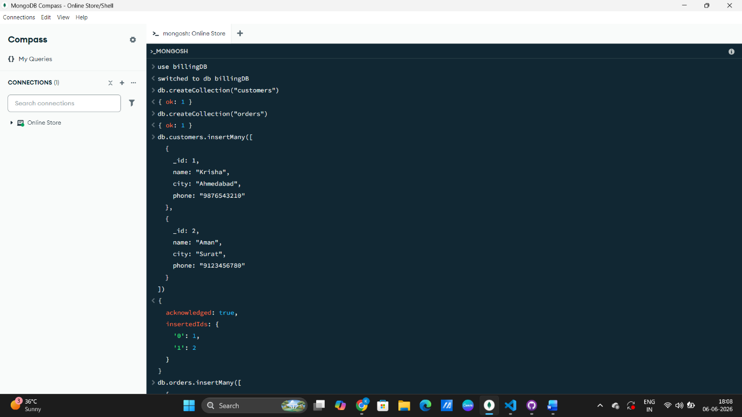

Task 3: Create customer master documents using mongodb:


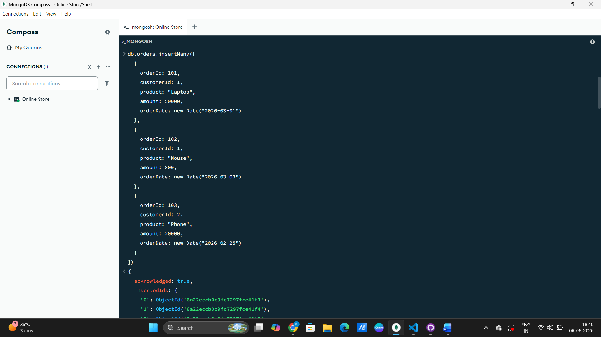
Task 4: Create order master document with reference to customer master:
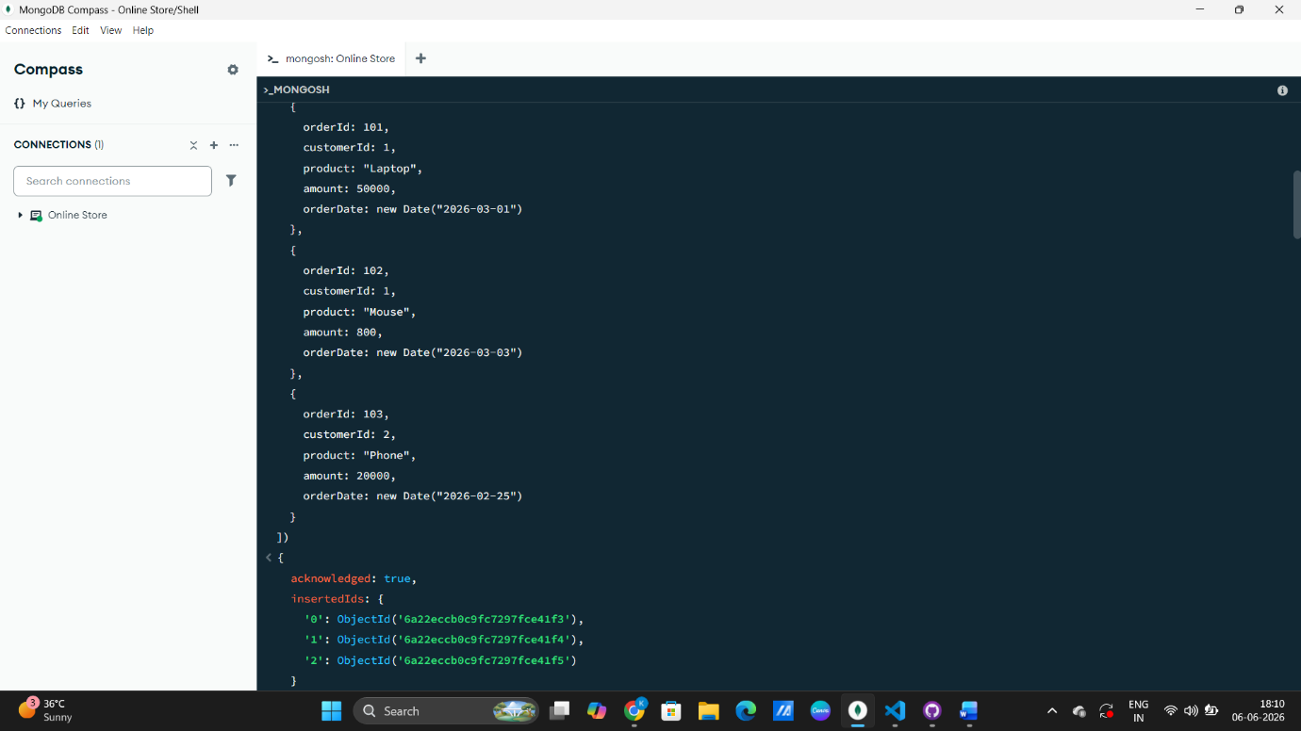

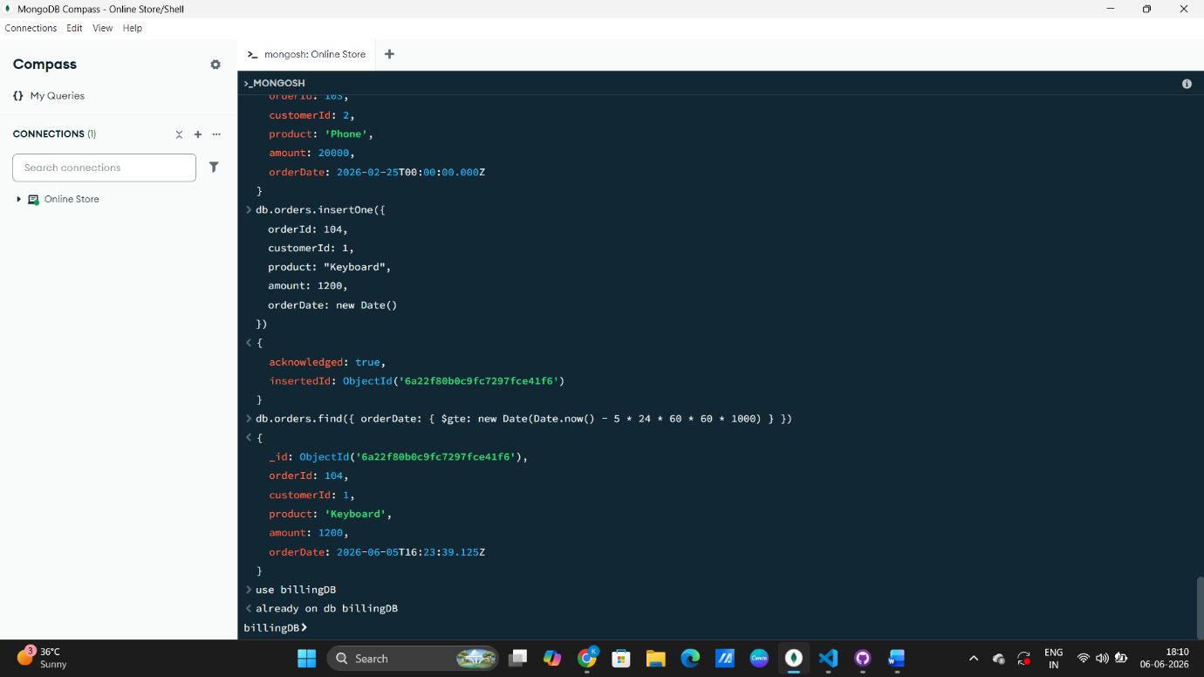
Task 5: Fetch order detail from documents which order given within 5 days:

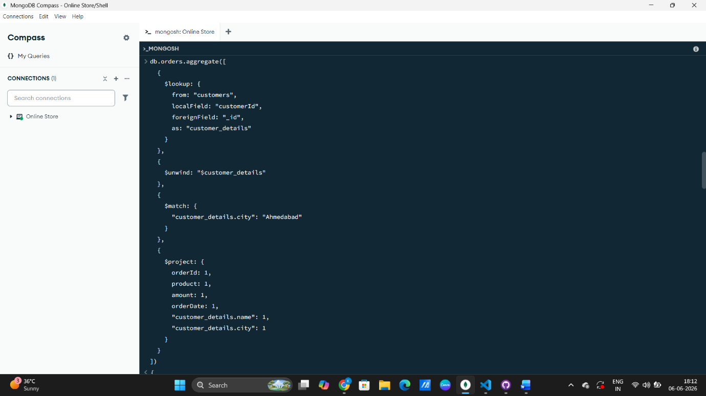
Task 6: Show order detail and customer detail who lives in Ahmedabad in table format:
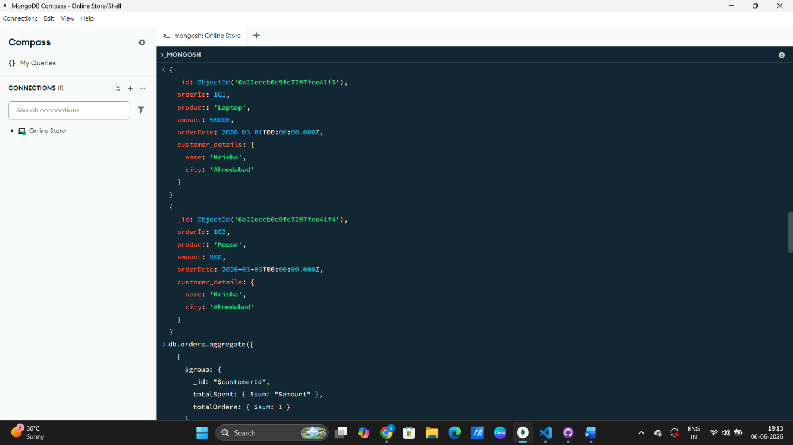

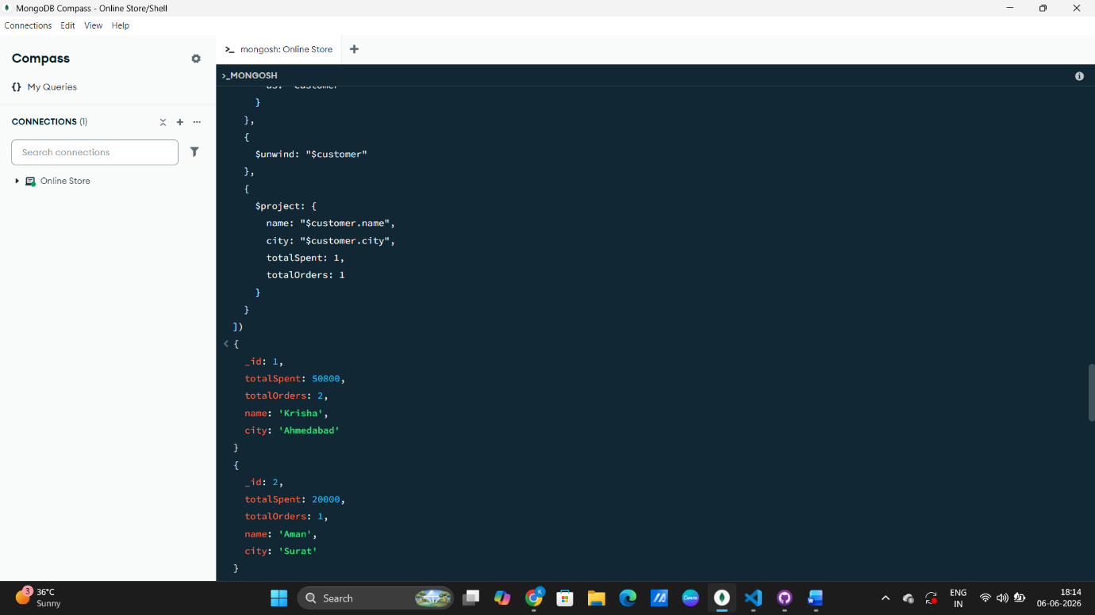
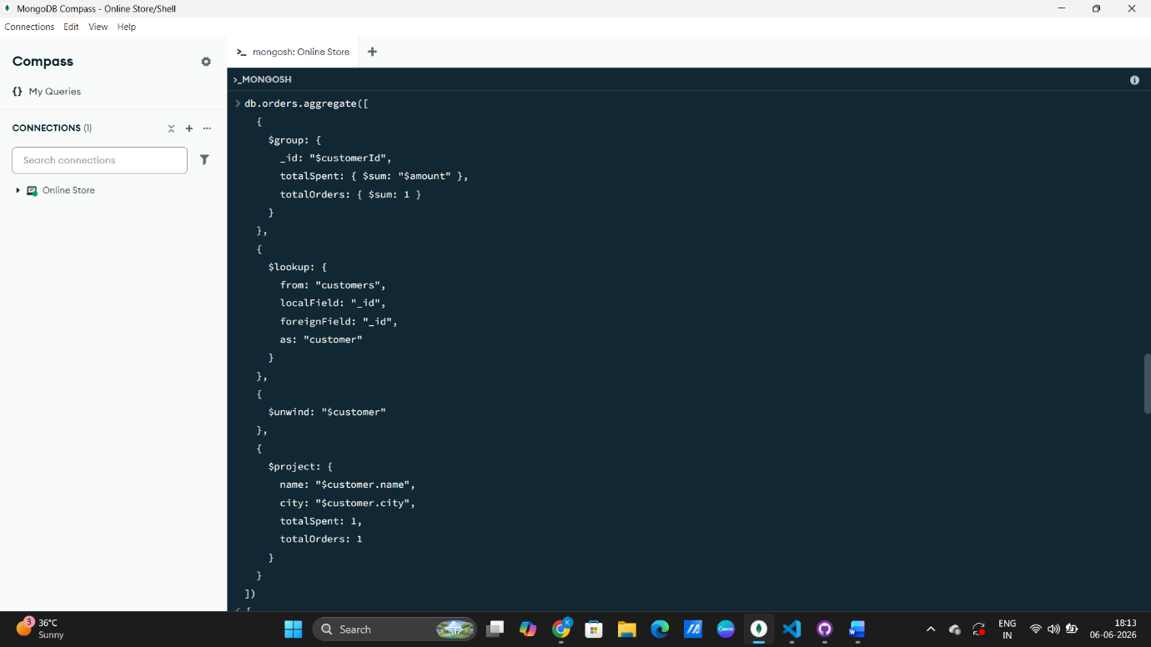
Task 7: Create a report on billing system of the order:

Task 8: Provide an API for taking orders from other applications:
const express = require("express");
const mongoose = require("mongoose");

const app = express();
const PORT = 3000;

// Middleware
app.use(express.json());

// MongoDB Connection
mongoose.connect("mongodb://127.0.0.1:27017/billingDB")
.then(() => console.log("MongoDB connected"))
.catch((err) => console.log("DB Error:", err));

// Schemas
// Customer Schema
const customerSchema = new mongoose.Schema({
name: String,
city: String,
phone: String
});

const Customer = mongoose.model("Customer", customerSchema);

// Order Schema
const orderSchema = new mongoose.Schema({
customerId: Number,
product: String,
amount: Number,
orderDate: Date
});

const Order = mongoose.model("Order", orderSchema);

// ROUTES
// Home route (IMPORTANT for browser)
app.get("/", (req, res) => {
res.send("Server is running successfully 🚀");
});

// Create Customer
app.post("/customer", async (req, res) => {
try {
const customer = new Customer(req.body);
await customer.save();
res.send("Customer created");
} catch (err) {
res.send(err.message);
}
});

// Create Order
app.post("/order", async (req, res) => {
try {
const order = new Order(req.body);
await order.save();
res.send("Order placed successfully");
} catch (err) {
res.send(err.message);
}
});

// Get All Orders
app.get("/orders", async (req, res) => {
const data = await Order.find();
res.json(data);
});

// Orders in last 5 days
app.get("/orders/recent", async (req, res) => {
const date = new Date();
date.setDate(date.getDate() - 5);

const data = await Order.find({
orderDate: { $gte: date }
});

res.json(data);
});

// Customer + Order JOIN (Ahmedabad filter)
app.get("/report/ahmedabad", async (req, res) => {
const data = await Order.aggregate([
{
$lookup: {
from: "customers",
localField: "customerId",
foreignField: "_id",
as: "customer"
}
},
{ $unwind: "$customer" },
{
$match: {
"customer.city": "Ahmedabad"
}
}
]);

res.json(data);
});

// Billing Report (Total per customer)
app.get("/report/billing", async (req, res) => {
const data = await Order.aggregate([
{
$group: {
_id: "$customerId",
totalSpent: { $sum: "$amount" },
totalOrders: { $sum: 1 }
}
},
{
$lookup: {
from: "customers",
localField: "_id",
foreignField: "_id",
as: "customer"
}
},
{ $unwind: "$customer" },
{
$project: {
name: "$customer.name",
city: "$customer.city",
totalSpent: 1,
totalOrders: 1
}
}
]);

res.json(data);
});

// Start Server
app.listen(PORT, () => {
console.log(`Server running on http://localhost:${PORT}`);
});

Output:
